Signature verification System using Python

- Background/ Problem Statement

Every person has a unique signature that is used primarily for personal identification and verification of important documents or legal transactions. Mostly used to authenticate checks, draughts, certificates, approvals, letters, and other legal documents. Because a signature is used in such critical activities, verification of its authenticity is essential.
This type of verification is critical in preventing document forgery and falsification in a variety of financial, legal, and commercial settings. Traditionally, signatures were manually verified by comparing them to copies of genuine signatures. This simple method may not be sufficient as technology advances, bringing with it new techniques for forgery and falsification of signatures.
So, in order to tackle such a problem new efficient tool is needed. Our Signature Verification System can help in the authentication of a handwritten signature by reducing human error.

- Working of the Project

Signature verification is the process of automatically and instantly determining whether a signature is genuine or not. Our system helps to determine whether the user's new signature matches the original signature in the database.
For the purpose of classifying the signature classification model, we have implemented a machine learning model. We will CNN for this. To test and see the results, we will take a sample signature (about 100 sample pictures of the same signature) and compare the sample pictures of the original signature with other random signatures.

- Advantages

- It automatically detects without any human supervision.
- A simple and effective method for identifying a person's signature.

- System Description

The system comprises 1 major module with their sub-modules as follows:

- User:

- User can sign in using the name, number, email, password, username, user’s photo, user age)
- Login in
- Users can log in using a username and password.
- Start matching
- The user will fill in two images, one will be the original image, and the second will be the comparison image.
- And get directed to the results page to see the results.

- Project Life Cycle

The waterfall model is a classical model used in the system development life cycle to create a system with a linear and sequential approach. It is termed a waterfall because the model develops systematically from one phase to another in a downward fashion. The waterfall approach does not define the process to go back to the previous phase to handle changes in requirements. The waterfall approach is the earliest approach that was used for software development.

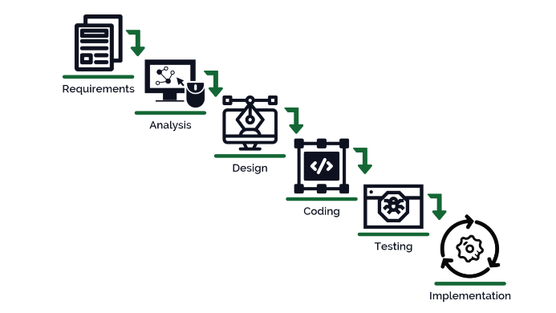

- System Requirements

- Hardware Requirement

- Laptop or PC
- Windows 7 or higher
- I3 processor system or higher
- 4 GB RAM or higher
- 100 GB ROM or higher

- Software Requirement

- Laptop or PC
- Python
- Sublime text Editor
- XAMP Server

- Limitation/Disadvantages
- Image quality has an impact on signature recognition.
- There's a possibility it won't be able to identify the signature if the background lighting is dim.

- Application – This system can instantly determine whether a person's signature is real or fake.

- Reference
- https://www.researchgate.net/publication/283556955_Signature_verification_using_Java_-_Python_for_small_computational_devices
- https://www.researchgate.net/publication/351322176_A_Review_-_Signature_Verification_System_Using_Deep_Learning_A_Challenging_Problem
- https://www.researchgate.net/publication/337084834_Offline_Signature_Verification_Using_Convolutional_Neural_Network_Undergraduate_Project_Subject_Code_CT_707
- https://www.ijcrt.org/papers/IJCRT2205942.pdf

